1. **Develop the HTML page named as “Myfirstwebpage.html”. Add the following tags with relevant content.**  
   **1.** Set the title of the page as “My First Web Page”  
   **2.** Within the body use the following tags:  
   **a)** Moving text = “Basic HTML Tags”  
   **b)** Different heading tags (h1 to h6)  
   **c)** Paragraph  
   **d)** Horizontal line  
   **e)** Line Break  
   **f)** Block Quote  
   **g)** Pre tag  
   **h)** Different Logical Style (< b >, < u >, < sub >, < sup > etc.)

Laboratory Components

1. HTML Basics "Myfirstwebpage.html" - Fundamental HTML tags and structures

2. HTML Tables "Table.html" - Create a class timetable with advanced table features

3. External CSS Styling "style.css" - Demonstrate various CSS selectors and styles

4. HTML Forms with CSS "registration.html" - Input elements styled with CSS

5. Semantic HTML and CSS "newspaper.html" - Use of semantic elements with

styling

6. JavaScript Calculator Simple calculator with multiple operations

7. JavaScript and JSON JSON manipulation, conversion, and hashing

8. PHP and Databases Visitor counter and database sorting with PHP

9. jQuery DOM Manipulation Content appending, animation, and color changing

10. Ajax Operations Ajax requests with and without jQuery, JSON handling

Explanation

**Step 1: Document Structure**

<!DOCTYPE html>: This declaration tells the browser that this is an HTML5 document.

<html lang="en">: The root element of the HTML page. The "lang" attribute specifies that

the language is English.

<head>: This section contains metadata about the document.

<body>: This section contains the visible content of the webpage.

**Step 2: The Head Section**

<meta charset="UTF-8">: Specifies the character encoding for the document (UTF-8

supports many languages).

<meta name="viewport" ...>: This tag helps with responsive design, making the page

display properly on different devices.

<title>: Sets the title of the webpage, which appears in the browser tab.

<link rel="stylesheet" href="style.css">: Links to an external CSS file for styling the page

Step 3: The Body Content

<marquee>: Creates scrolling text (Note: This tag is outdated and not recommended for modern websites).

Headings: <h1> to <h6> tags represent six levels of section headings, with <h1> being the

highest (most important) and <h6> the lowest.

<p>: Defines a paragraph of text.

<hr>: Creates a horizontal line, often used to separate content.

<br>: Inserts a single line break.

<blockquote>: Used for quoting content from another source.

<pre>: Defines preformatted text, which preserves both spaces and line breaks.

Step 4: Text Formatting

<b> and <strong>: Both typically display text in bold. <strong> is preferred as it adds

semantic meaning of strong importance.

<i> and <em>: Both typically display text in italics. <em> is preferred as it adds semantic meaning of emphasis.

<u>: Underlines text (use with caution as it can be confused with hyperlinks).

<sub>: Defines subscript text.

<sup>: Defines superscript text.

Code:index.html

<!DOCTYPE html>

<html lang="en">

<head>

    <meta charset="UTF-8">

    <meta name="viewport" content="width=device-width, initial-scale=1.0">

    <title>My First Web Page |VNEC</title>

</head>

<body>

        <marquee>Welcome to VNEC </title></marquee>

   <!-- Different heading tags -->

    <h1>This is an H1 heading</h1>

    <h2>This is an H2 heading</h2>

    <h3>This is an H3 heading</h3>

    <h4>This is an H4 heading</h4>

    <h5>This is an H5 heading</h5>

    <h6>This is an H6 heading</h6>

    <!-- Paragraph -->

<p>This is a paragraph demonstrating the use of the paragraph tag in HTML.</p>

    <!-- Horizontal line -->

    <hr>

    <!-- Line break -->

    <p>This is a line of text before the break.<br>This is a line of text after the break.</p>

    <!-- Block Quote -->

    <blockquote>

        This is a blockquote. It is used to display a quotation or excerpt from another source.

    </blockquote>

    <!-- Pre tag -->

    <pre>

        This is preformatted text.

        It preserves spaces and line breaks.

    </pre>

    <!-- Different Logical Style tags -->

    <p>This is <b>bold</b> text.</p>

    <p>This is <i>italicized</i> text.</p>

    <p>This is <u>underlined</u> text.</p>

    <p>This is <sup>superscript</sup> text.</p>

    <p>This is <sub>subscript</sub> text.</p>

    <p>This is <em>emphasized</em> text.</p>

    <p>This is <strong>strong</strong> text.</p>

    <p>This is <mark>highlighted</mark> text.</p>

    <p>This is <small>small</small> text.</p>

    <p>This is <del>deleted</del> text.</p>

    <p>This is <ins>inserted</ins> text.</p>    <p>This is <code>inline code</code> text.</p>

</html>

Output:

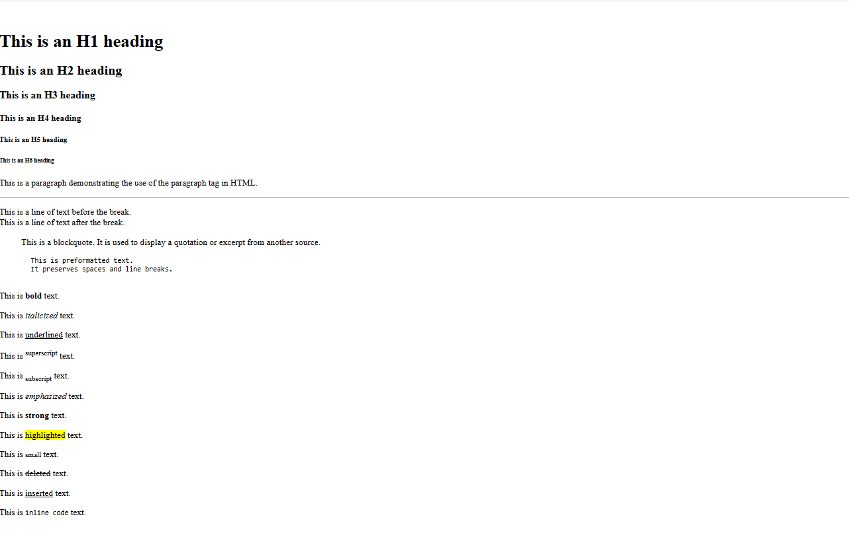

**Explanation**

**Step 1: Document Structure**

The document starts with the standard HTML5 declaration and structure. The <head> section contains metadata and styling information. The <body> section contains the visible content, which in this case is a table.

**Step 2: Styling (CSS)**

The <style> tag in the <head> section defines the appearance of the table and its elements. It sets the font, adjusts spacing, and defines colors for different types of classes. Specific classes are created for lab hours, elective hours, lunch, and alternating row colors.

**Step 3: Table Structure**

The table is created using the <table> tag. It has three main parts: <thead> (table header), <tbody> (table body), and <tfoot> (table footer).

**Step 4: Table Header ()** The first row spans all columns and displays "Class Time Table". The second row shows the days of the week and a "Time" column.

**Step 5: Table Body ()** Each represents a row in the timetable. The first column in each row shows the time slot. Subsequent columns represent different subjects for each day. Special formatting is applied to certain cells: Lab hours are highlighted in pink. Elective hours are highlighted in light green. The lunch break spans across multiple columns. The "Saturday" column spans multiple rows to show "No Classes". Alternate rows have a slightly different background color for better readability.

**Step 6: Special Cell Attributes** colspan is used to make cells span multiple columns (e.g., for labs and lunch). rowspan is used to make the "Saturday" cell span multiple rows. Classes are applied to cells for specific styling (e.g., "lab-hours", "elective-hours").

**Step 7: Table Footer ()** The footer provides a legend explaining the color coding used in the table. This HTML document demonstrates several important concepts: Table structure and formatting Use of CSS for styling Cell spanning (both rows and columns) Color coding for different types of classes Responsive design considerations (though the table itself isn't responsive)

**Experiment-02**

**2.Develop the HTML page named as “Table.html” to display your class time table.**

a) Provide the title as Time Table with table header and table footer, row-span and

col-span etc.

b) Provide various colour options to the cells (Highlight the lab hours and elective

hours with different

colours.)

c) Provide colour options for rows.

Code:

<!DOCTYPE html>

<html lang="en"></html>

<head>

    <meta charset="UTF-8">

    <meta name="viewport" content="width=device-width, initial-scale=1.0">

    <title>Time Table | vtucode</title>

    <style>

        body {

            font-family: Arial, sans-serif;

        }

        table {

            width: 80%;

            margin: 20px auto;

            border-collapse: collapse;

        }

        th, td {

            border: 1px solid #ddd;

            padding: 8px;

            text-align: center;

        }

        th {

            background-color: #f4f4f4;

            color: #333;

        }

        tr:nth-child(even) {

            background-color: #f9f9f9;

        }

        tr:nth-child(odd) {

            background-color: #e6f7ff;

        }

        .lab-hour {

            background-color: #ffcccc;

        }

        .imp-sub{

            background-color: slateblue;

        }

        .elective-hour {

            background-color: #ccffcc;

        }

        .highlight {

            font-weight: bold;

            color: #d63384;

        }

        tfoot {

            background-color: #e0e0e0;

            font-weight: bold;

        }

    </style>

</head>

<body>

    <h1 style="text-align: center;">VNEC CSE</h1>

    <h2 style="text-align: center;">CLASS TIME TABLE OF ACADEMIC YEAR-2025-26(ODD)</h2>

   <p style="padding-left: 200px;">SEM:VI A&B</p>

    <table>

        <thead>

            <tr>

                <th>Day/Time</th>

                <th>Session 1 9:45am - 11:15am</th>

                <th>Session 2 11:30am - 1:00pm</th>

                <th> 1:00pm - 1:45pm</th>

                <th>Session 3 1:45pm - 3:15pm</th>

                <th>Session 4 3:30pm - 4:50pm</th>

            </tr>

        </thead>

        <tbody>

            <tr>

                <td>Monday</td>

                <td>RM</td>

                <td class="imp-sub">AI</td>

                <td rowspan="6" class="highlight">Lunch Break</td>

                <td >TOC</td>

                <td class="lab-hour">CN Lab B 1</td>

            </tr>

            <tr>

                <td>Tuesday</td>

                <td class="elective-hour">SEPM</td>

                <td>RM</td>

                <td>CN</td>

                <td class="lab-hour">WEB  Lab 2</td>

            </tr>

            <tr>

                <td>Wednesday</td>

                <td>TOC</td>

                <td class="imp-sub">AI</td>

                <td class="elective-hour">SEPM</td>

                <td class="lab-hour">CN  Lab 2</td>

            </tr>

            <tr>

                <td>Thursday</td>

                <td>CN</td>

                <td>TOC</td>

                <td class="lab-hour">WEB  Lab 1</td>

                <td>Mini Project</td>

            </tr>

            <tr>

                <td>Friday</td>

                 <td class="imp-sub">AI</td>

                <td>CN</td>

                <td>BNSK508</td>

                <td>Mini Project</td>

            </tr>

            <tr>

                <td>Saturday</td>

                <td class="elective-hour">SEPM</td>

                <td>TOC</td>

                <td colspan="2">NSS/PE/YOGA</td>

            </tr>

        </tbody>

        <tfoot>

            <tr>

                <td colspan="8">End of Timetable</td>

            </tr>

        </tfoot>

    </table>

</body>

</html>

OutPut: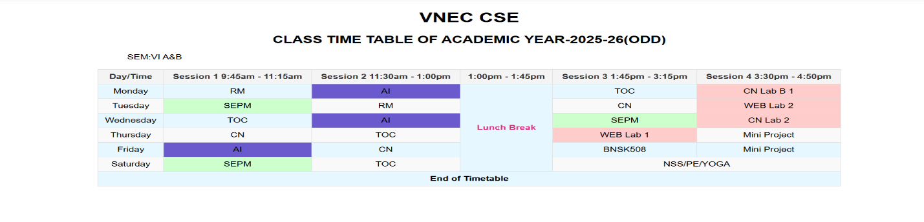

**3.Develop an external style sheet named as “style.css” and provide different styles for h2, h3, hr, p, div, span, time, img & a tags. Apply different CSS selectors for tags and demonstrate the significance of each.**

***Note: make two file one is style.css and other is index.html then type the below code for different file.***

<!DOCTYPE html>

<head>

    <title>Styled HTML Page </title>

    <link rel="stylesheet" href="3exp.css">

</head>

<body>

    <h2>Main Heading</h2>

    <h3>Subheading</h3>

    <hr>

    <p>This is a paragraph demonstrating the basic text styling applied by CSS.</p>

    <div>

        This is a styled <strong>div</strong> element with padding and a light border. Inside the div, we can also use

        <span>span elements</span> that have their own styles, like this bold and orange text.

    </div>

    <p>Current time: <time>10:30 AM</time></p>

    <img src="http://veerappanistyecs.org/assets/img/slide/appa.png" alt="Placeholder Image">

    <p>Visit <a href="http://veerappanistyecs.org/">http://veerappanistyecs.org/</a> to know more about our college.</p>

    <p class="highlight">This paragraph is highlighted with a yellow background.</p>

    <p class="center">This text is centered using a class selector.</p>

    <p id="special-paragraph">This is a special paragraph with unique styles applied through an ID selector.</p>

</body>

</html>

**Style.css:**

* {

    margin: 0;

    padding: 0;

    box-sizing: border-box;

}

h2 {

    color: #2c3e50;

    font-size: 2em;

    margin-bottom: 10px;

}

h3 {

    color: #34495e;

    font-size: 1.5em;

    margin-bottom: 8px;

}

hr {

    border: 0;

    height: 2px;

    background-color: #e74c3c;

    margin: 20px 0;

}

p {

    font-family: 'Arial', sans-serif;

    line-height: 1.6;

    margin: 10px 0;

}

div {

    padding: 15px;

    border: 1px solid #bdc3c7;

    background-color: #ecf0f1;

}

span {

    color: #e67e22;

    font-weight: bold;

}

time::before {

    content: '⏰ ';

    color: #16a085;

}

img {

    margin-left: 15px;

    height: 300px;

    width: 400px;

    border-radius: 8px;

    box-shadow: 0 4px 8px rgba(0, 0, 0, 0.2);

    max-width: 100%;

}

a {

    text-decoration: none;

    color: #ea0e4c;

}

a:hover {

    color: #6200ee;

    text-decoration: underline;

}

.highlight {

    background-color: yellow;

    padding: 3px;

}

.center {

    text-align: center;

}

#special-paragraph {

    font-size: 1.2em;

    color: #8e44ad;

    background-color: #f5f5f5;

    padding: 10px;

    border-left: 5px solid #8e44ad;

}

h2,h3,p {

    margin-left: 20px;

}

**Explanation**

**Step 1: HTML Structure**

The document starts with the standard HTML5 declaration and basic structure.

The <head> section includes metadata, title, and a link to an external CSS file (style.css).

The <body> contains a <main> element with the id "main-content", which holds all the visible content.

**Step 2: Main Content Structure**

The main content includes various HTML elements like h2, h3, p, hr, section, article, img, and a. These elements demonstrate different CSS selectors and properties.

**Step 3: CSS Styling (from style.css)**

**Element Selectors:**

h2: Styled with color, font-family, border-bottom, and padding.

h3: Has a hover effect changing color with a transition.

hr: Styled as a gradient line.

Attribute Selectors:

Class Selector: p[lang]: Applies italic style to paragraphs with a lang attribute.

time[datetime]: Styles time elements with a datetime attribute.

img[alt]: Ensures responsive sizing for images with alt text.

.highlight: Applies background color and padding.

ID Selector: #main-content: Sets max-width, margin, padding, and background color.

Descendant Selector:

div p: Styles paragraphs inside divs (note: no divs in this HTML, so this won't apply).

Child Selector:

div > span: Styles spans that are direct children of divs (also won't apply here).

Adjacent Sibling Selector:

h2 + p: Styles paragraphs immediately following h2 elements.

Pseudo-element Selector:

p::first-letter: Styles the first letter of each paragraph.

Multiple Selectors:

img, a: Applies border and padding to both images and links.

Pseudo-class Selectors for Links:

Combining Selectors:

a:link, a:visited, a:hover, a:active: Different styles for various link states.

div.special p: Would style paragraphs in divs with class "special" (not applicable here).

**Step 4: Specific Content and Styling Examples**

The h2 and following p demonstrate the adjacent sibling selector.

The h3 has a hover effect.

A paragraph with lang="en" shows the attribute selector in action.

The "highlight" class is applied to a span within a paragraph.

A section with a paragraph and span demonstrates descendant and child selectors

(though the CSS for div won't apply).

The <time> element shows the datetime attribute selector.

An article with class="special" is included, but the CSS for div.special won't apply.

An image and a link are included to demonstrate various selectors and responsive

design.

OutPut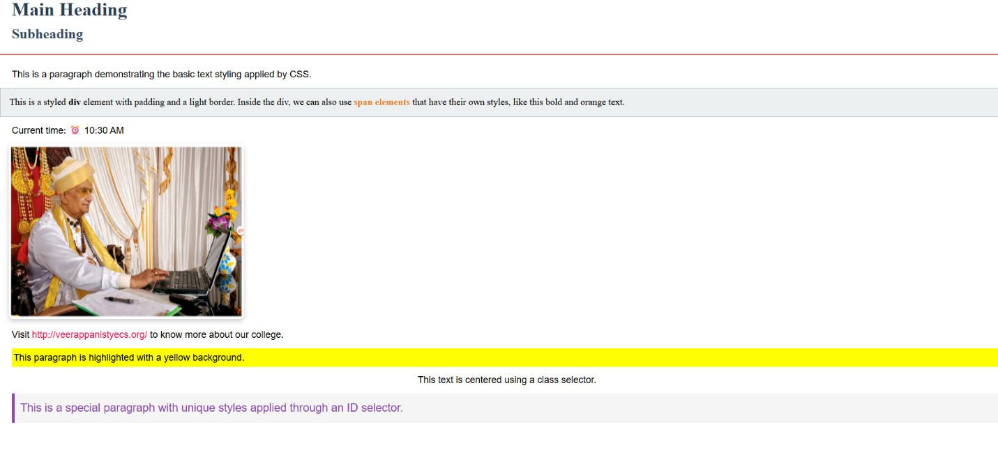

**4.Develop HTML page named as “registration.html” having variety of HTML input elements with background colors, table for alignment & provide font colors & size using CSS styles.**

**Index.html**

<!DOCTYPE html>

<head>

    <title>Registration Form | VTU CSE VNEC</title>

    <style>

        body {

            font-family: Arial, sans-serif;

            background-color: #f0f4f8;

            margin: 0;

            padding: 20px;

            display: flex;

            justify-content: center;

            align-items: center;

            min-height: 100vh;

        }

        .container {

            width: 100%;

            max-width: 600px;

            background-color: #fff;

            padding: 20px;

            border-radius: 8px;

            box-shadow: 0 0 10px rgba(0, 0, 0, 0.1);

            display: flex;

            flex-direction: column;

            gap: 20px;

        }

        h2 {

            text-align: center;

            color: #333;

            margin: 0;

        }

        .form-group {

            display: flex;

            flex-direction: column;

            gap: 5px;

            margin-bottom: 10px;

        }

        label {

            font-size: 14px;

            color: #555;

        }

        input[type="text"],

        input[type="email"],

        input[type="password"],

        input[type="date"],

        select,

        textarea {

            padding: 10px;

            border: 1px solid #ccc;

            border-radius: 4px;

            font-size: 14px;

        }

        .gender-options {

            display: flex;

            gap: 10px;

            align-items: center;

        }

        input[type="submit"],

        input[type="reset"] {

            padding: 10px 20px;

            border: none;

            border-radius: 4px;

            cursor: pointer;

            font-size: 16px;

            flex: 1;

        }

        .button-group {

            display: flex;

            gap: 10px;

            justify-content: center;

        }

        input[type="submit"] {

            background-color: #4CAF50;

            color: white;

        }

        input[type="reset"] {

            background-color: #f44336;

            color: white;

        }

        .form-group textarea {

            margin-bottom: 10px;

        }

    </style>

</head>

<body>

    <div class="container">

        <h2>Registration Form</h2>

        <form action="#" method="post">

            <div class="form-group">

                <label for="firstName">First Name:</label>

                <input type="text" id="firstName" name="firstName" required>

            </div>

            <div class="form-group">

                <label for="lastName">Last Name:</label>

                <input type="text" id="lastName" name="lastName" required>

            </div>

            <div class="form-group">

                <label for="email">Email:</label>

                <input type="email" id="email" name="email" required>

            </div>

            <div class="form-group">

                <label for="password">Password:</label>

               <input type="password" id="password" name="password" required>

            </div>

            <div class="form-group">

                <label for="dob">Date of Birth:</label>

                <input type="date" id="dob" name="dob">

            </div>

            <div class="form-group">

                <label>Gender:</label>

                <div class="gender-options">

                <input type="radio" id="male" name="gender" value="male">

                <label for="male">Male</label>

               <input type="radio" id="female" name="gender" value="female">

                <label for="female">Female</label>

                </div>

            </div>

            <div class="form-group">

                <label for="country">Country:</label>

                <select id="country" name="country">

                    <option value="usa">USA</option>

                    <option value="canada">Canada</option>

                    <option value="uk">UK</option>

                    <option value="india">India</option>

                </select>

            </div>

            <div class="form-group">

                <label for="bio">Bio:</label>

                <textarea id="bio" name="bio" rows="4"></textarea>

            </div>

            <div class="button-group">

                <input type="submit" value="Register">

                <input type="reset" value="Reset">

            </div>

        </form>

    </div>

</body>

</html>

**OutPut:**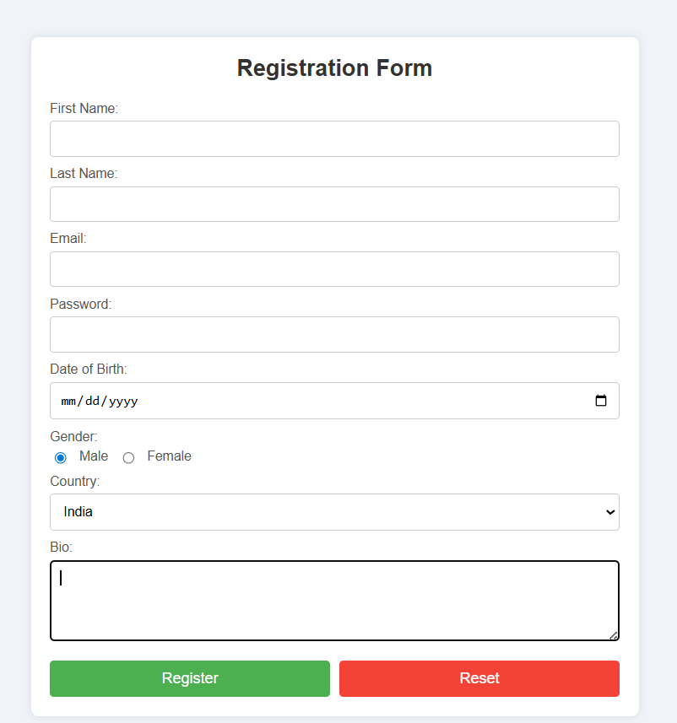

**Explanation**

**Step 1: Document Structure**

The document starts with the standard HTML5 declaration and structure. The <head> section contains metadata, title, and embedded CSS styles. The <body> section contains the form.

**Step 2: Styling (CSS)**

The style section defines the appearance of the form and its elements. It sets the font, colors, layout, and responsive design for the form. Specific styles are applied to different input types, labels, and the submit button. A class for error messages is defined but not used in the HTML.

**Step 3: Form Structure**

The form is created using the <form> tag with a placeholder action "#". A table is used to structure the form layout.

**Step 4: Form Fields**

The form includes the following fields:

Full Name (text input)

Email (email input)

Password (password input)

Confirm Password (password input)

Gender (radio buttons)

Date of Birth (date input)

Country (select dropdown)

Interests (checkboxes)

Bio (textarea)

Submit button

**Step 5: Input Attributes and Validation**

Most fields are marked as required. Appropriate input types are used (e.g., email for email address, date for birthdate). The password field has a confirmation field. The country dropdown includes a default "Select a country" option.

**Step 6: Styling Details** The form has a white background with rounded corners and a shadow. Input fields have consistent styling with padding and border-radius. The submit button has a green color with a hover effect. The layout is responsive, with a maximum width set for larger screens. This registration form demonstrates several important concepts: HTML form structure and various input types Basic client-side form validation using HTML5 attributes Responsive design using CSS Styling form elements for a consistent and appealing look Use of tables for form layout (though modern practices often prefer CSS grid or flexbox).

**Experiment-05**

**5.Develop HTML page named as “newpaper.html” having variety of HTML**

**semantic elements with background colors, text-colors & size for figure, table,**

**aside, section, article, header, footer… etc**